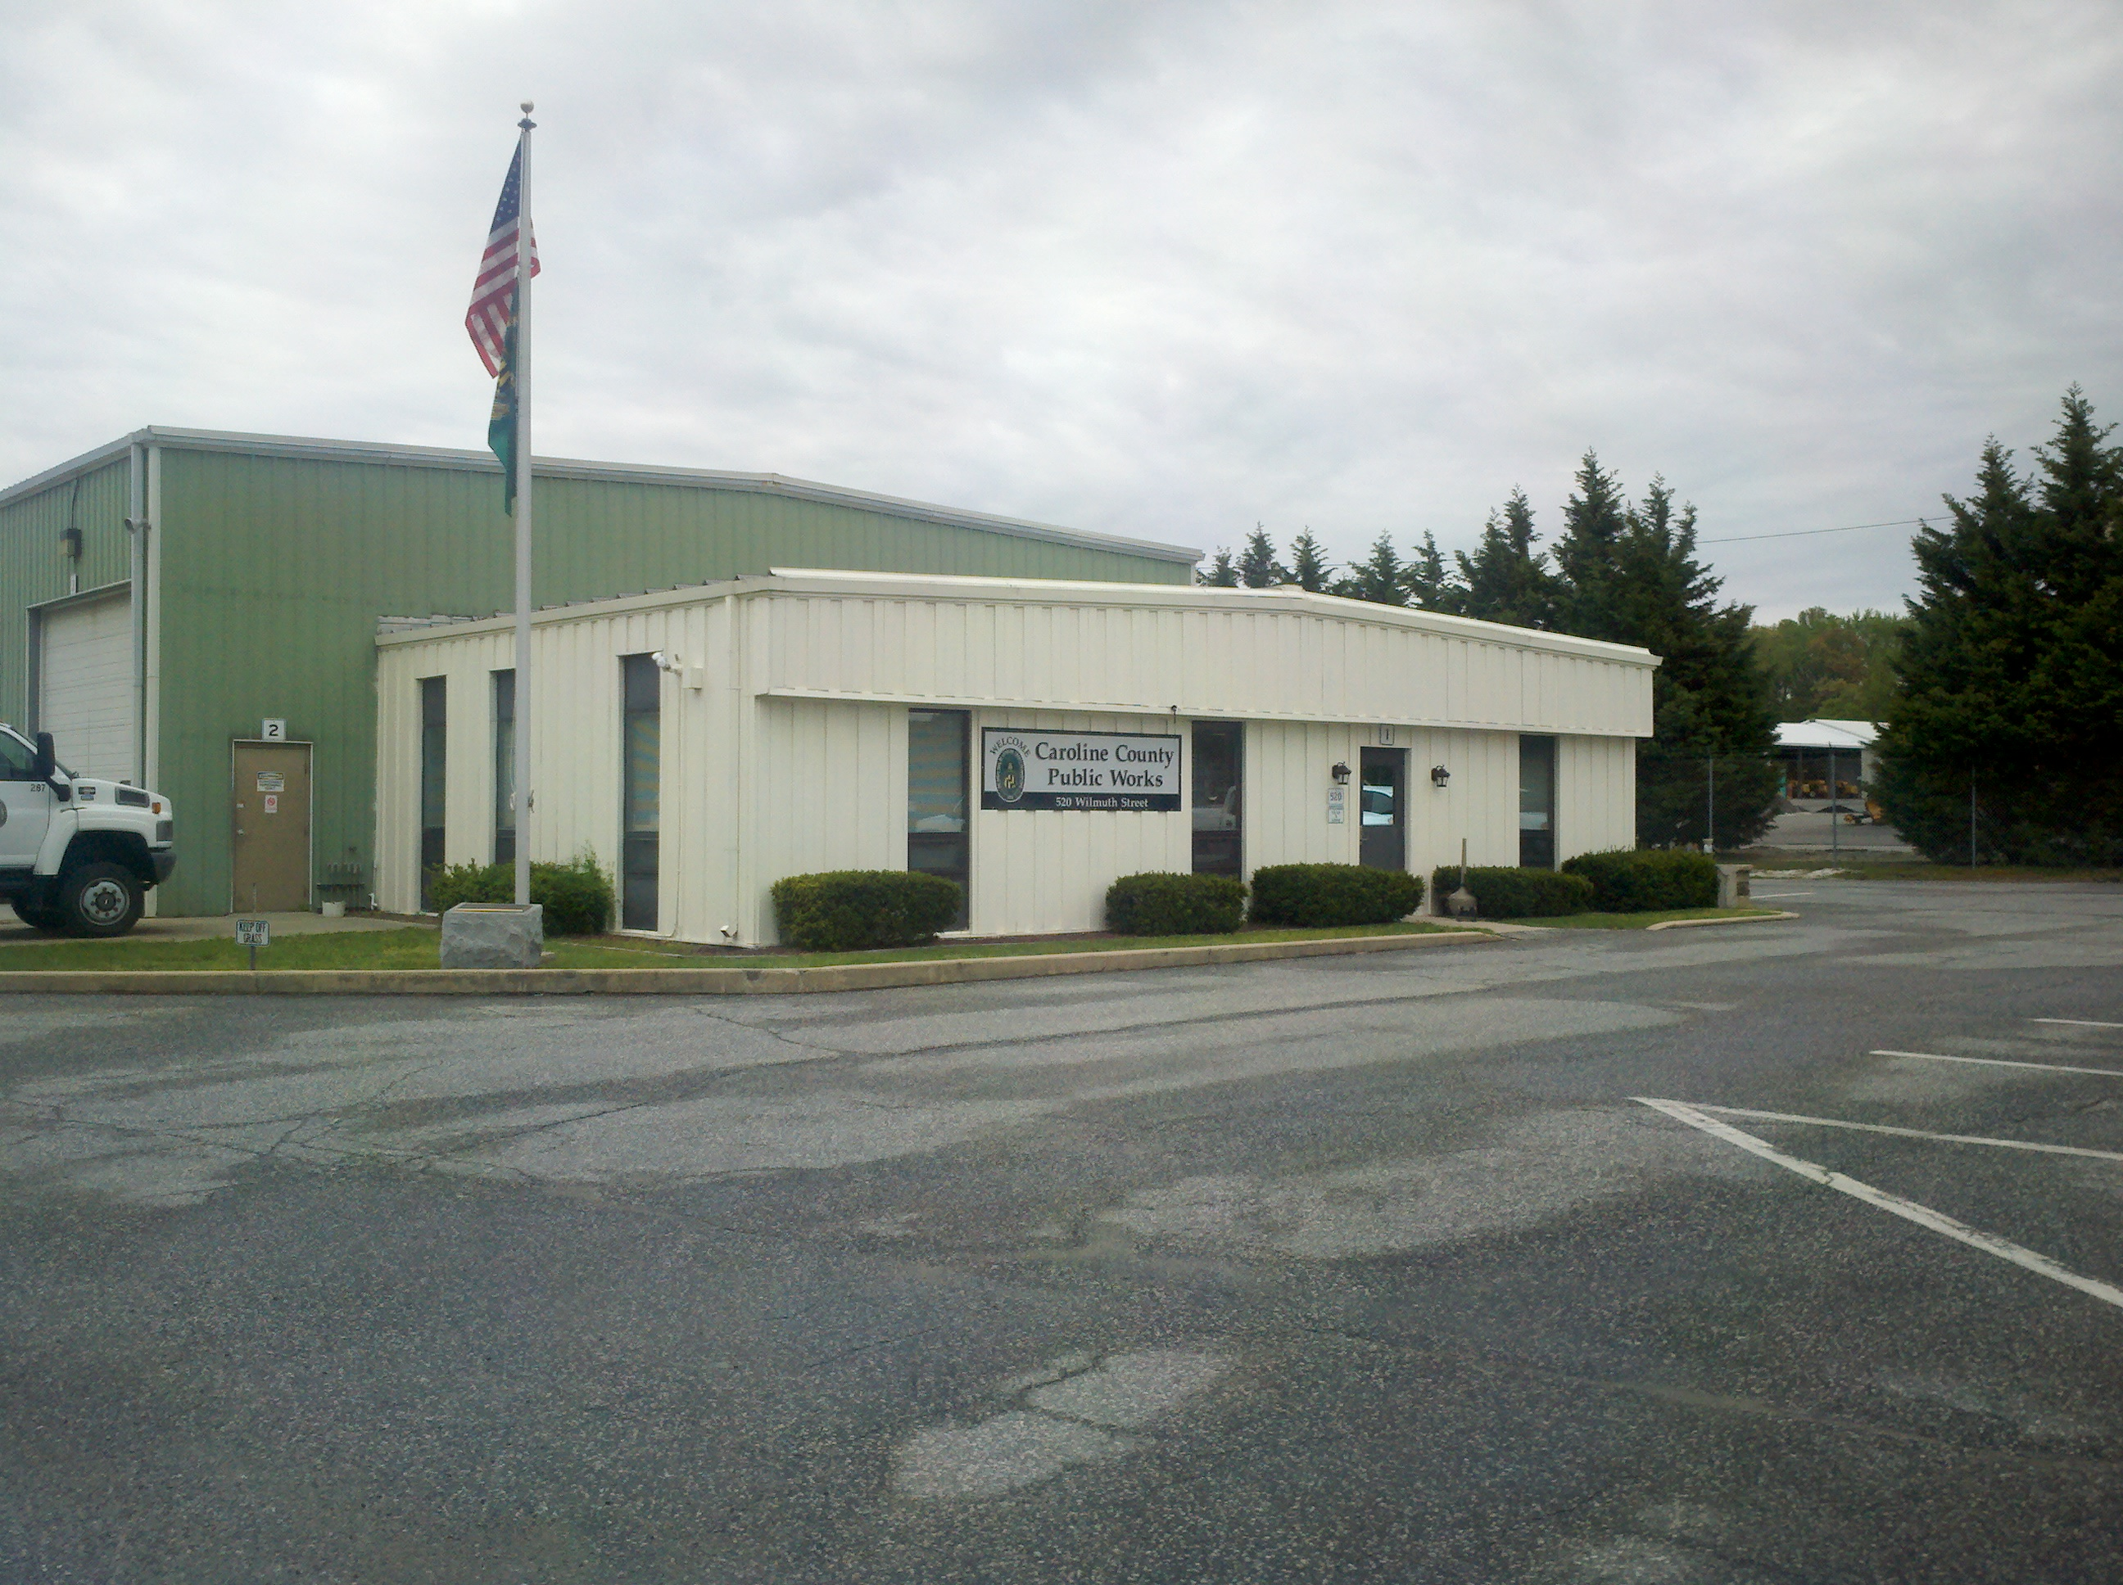  Caroline County Public Works Building  Please read carefully before signing up for the program:  Please review your invoice/application and return with payment to Caroline County Public Works to remain or enroll in the spray program.  If you are interested, please complete the application. On the back of the form provide a sketch describing your property with preferred spray route. Submit this form only, DO NOT ATTACH ( staple, tape, clip) maps, additional papers, Google Earth maps etc. as this application is copied and carried in our master logbook. Any questions, please feel free to call.  Please make sure your house number is clearly visible to or operator. While our employees will do their best to respect your property, the County will not be responsible for any damage that may occur as a result of our spraying operations. We hope every customer is fully satisfied. If there are any issues with the service, please call us. We hope we can iron out any issues, but we are obliged to tell you that we reserve the right to suspend or cancel service.
  About Us
  Caroline County provides a fee-for-service mosquito control program. The employees who provide the service are certified by the Maryland Department of Agriculture (MDA) and follow all the applicable laws, rules, and regulations. Any concerns or questions about the program may be directed to Mr. Jeff Garrett, the Program Coordinator of Caroline County.
  Contact Us
  Jeff Garrett, Mosquito Control Coordinator MDA Permit 6204/ Public Agency Permit 30339
  Phone: (410)479-0520
  Email: jgarrett@carolinemd.org or jclendaniel@carolinemd.org
  Web: www.carolinemd.org
  Cost and Place of Payment
  As of January 2024, the cost is $165 per acre and $ 4 for each additional acre. We accept cash or checks as payment. Please come into our office or mail your application, map, and payment to Caroline County Public Works at 520 Wilmuth St in Denton, MD 21629.
  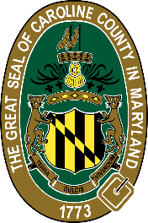 |  | Caroline County Public Works  520 Wilmuth St  Denton, MD 21629
  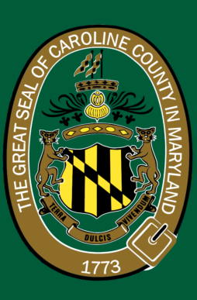
  Caroline County Public Works
    - MOSQUITO CONTROL PROGRAM

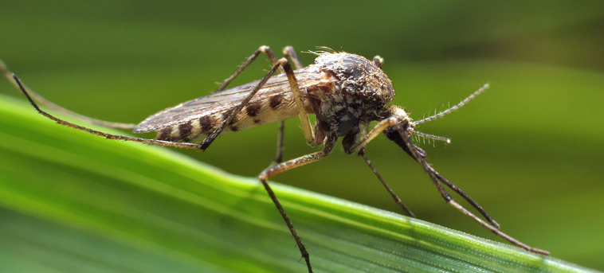  Mosquito Control Program Standard Procedures  When we spray:  Before we spray, our employees conduct a field test for the density of adult mosquitos. When there are enough mosquitos as verified by the test, we spray. If not, we don’t. We also monitor for conditions that threaten public health and may set “light traps” to capture and test mosquitos to see if they are carrying illness. If the light traps capture enough mosquitos, we spray. Additional details on our mosquito testing protocols can be found on the County’s website.  We conduct normal spraying every day of the week except Saturday and Sunday. We reserve the right to spray on any day. Normal hours of operation are from dusk to dawn. The program begins in May and ends in October. The actual start and stop dates depend on mosquito populations and guidelines from the State.  What to expect:  Our employees spray for mosquitos early in the morning. We use truck-mounted equipment and normally follow a specific route. We try not to disturb residents. The ULV spray we use is a “knock down” formula. It kills mosquitos on contact and reduces mosquito populations but does not eliminate them. |  |  | When we don’t spray:  We do not spray during the rain, when the wind speed exceeds 10mph, when the temperature is higher than 85 degrees, or when other conditions exist where spraying cannot be conducted safely. Due to regulations, we do not spray after 8:00AM. We avoid spraying around people. If the ground is too wet due to weather and our vehicle may get stuck, we will forgo those areas until the ground dries up and we can get our vehicle in and out safely.  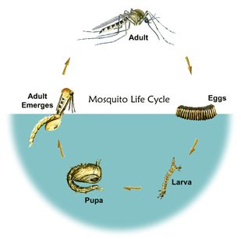  What we use:  The County’s program uses an ultra-low volume (ULV) “adulticide” formula to control adult mosquitos. This consists of Permananone 30-30, Permethrin mixed in a concentration of 1:4 with CVA oil. To combat mosquito larvae, we use a larvicide consisting of Altosid (Methoprene) in a liquid, pellet, or charcoal briquette. If you would like copies of the Material Safety Data Sheet (MSDS) or other information, please contact Jeff Garrett. |  |  | 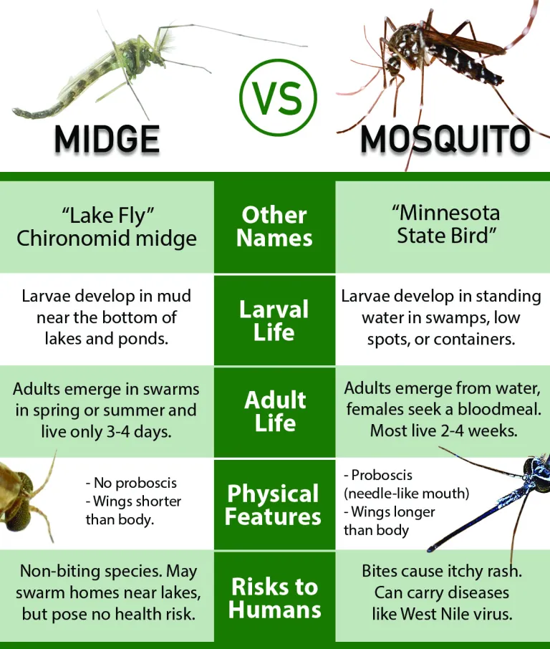  Differences between Midges and Mosquitos  Midges/Flies:  The County’s program does not spray for midges. These non-biting insects swarm on homes, boats, trees, and shrubs generally near water. The midge population normally surges for a few weeks and the dissipates. We are not allowed to spray for flies (even biting flies).  How to file an objection to stop spraying nearby:  This is a subscription program where residents sign up for the service; however, we do provide services to local municipal governments and community associations. We understand some residents may not want mosquito spraying to occur nearby. To file an objection, please call Jeff Garrett or follow the direction on the Maryland Department of Agriculture (MDA) website.

